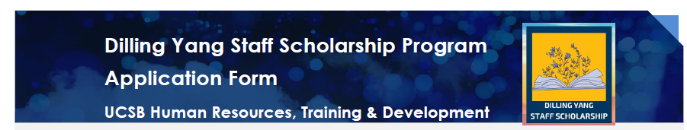

Instructions

Submit completed application via HR ServiceNow>>Training & Development>>
Dilling Yang Staff Scholarship and upload and attach any documentation verifying enrollment in and any payment of fees for non-HR Training courses with your HR ServiceNow ticket.

If you have any questions, please email barb.freeman@hr.ucsb.edu or call x-3133.

Employee Information
Lived Name |  | Dept Code/Dept Name
Employee ID |  | Email/Phone
Job Code/Job Title |  | Length of UCSB Employment
Supervisor Name |  | Supervisor Email
Request Course Type (i.e., HR Training, PaCE course, or Academic course) |  | PERM Number if requesting funds for Academic Course
Quarter/Year Scholarship is Requested For |  | TOTAL Scholarship Amount Requested | $
1. Course/Conference |  | Date: | $
2. Course/Conference |  | Date: | $
3. Course/Conference |  | Date: | $
4. Course/Conference |  | Date: | $
5. Course/Conference |  | Date: | $
6. Course/Conference |  | Date: | $

Below, please explain the reasons why you are submitting an application for a Dilling Yang Staff Scholarship Award including how the UCSB course/conference meets your professional development and/or educational goals and how it will enhance your job skills. If you prefer, you may type your explanation and attach the document to your application.

Employee Signature |  | Date
Supervisor Signature |  | Date
HR Training Approval Signature |  | Date |  | Scholarship Awarded | $

